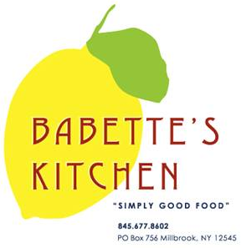
Holiday Menu Advance Order Form

Orders must be placed by Monday, December 18th.
Pick-Ups can be scheduled for Saturday, December 23rd or Sunday, December 24th
We will be closed on Christmas Day. Have a wonderful Holiday.

Please indicate in the first column the quantity of each item that you would like to order.

Quantity | Unit | Menu Item | Price
 | pound | Roast Sirloin of Beef | $24
 | quart | Coq Au Vin (serves 2-3) | $25
 | serves 9 | Vegetable Lasagna | $80
 | serves  9 | Shrimp Scampi Lasagna | $130
 | quart | Corn Pudding  Serves 4-6 | $16
 | quart | Mashed Potatoes | $15
 | pound | Roasted Brussel Sprouts and Cauliflower w/Shallots | $12
 | each | Baguettes | $4
 | dozen | Mini Biscuits | $10
 | each | Quiche Lorraine | $20
 | each | Veggie Quiche | $20
**All scones, muffins and croissants 6 minimum per order.

 | Unit | Menu Item | Price
 | each | Chocolate Babka | $18
 | each | Buche De Noel | $55
 | each | Maple Crumb Apple Pie | $25
 | each | Cranberry Orange Cornmeal Cake | $22
 | dozen | Assorted Holiday Cupcakes | $48
 | serves  8-10 | Assorted Holiday Cookie Platter | $30
 | each | Gluten Free  Chocolate Raspberry  Cheesecake | $45  8 inch
 | each | Croissants | $3
 | each | Chocolate Croissants | $3.50
 | each | Cranberry Scones | $4
 | each | Blueberry Muffins | $2.50
 | each | Gluten Free Blueberry Muffins | $3.00

Name: _______________________________________
Phone number: _________________________________
Pick-up day and time:
Saturday, December 23rd 10am 11am 12pm 1pm Later
Sunday, December 24th 10am 11am 12pm 1pm 2pm

