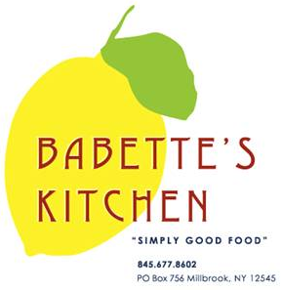
Holiday Menu Advance Order Form

Orders must be placed by Friday, December 16th
Pick-Ups can be scheduled for Friday, December 23rd or Saturday, December 24th
We will be closed on Christmas Day. Have a wonderful Holiday.

Please indicate in the first column the quantity of each item that you would like to order.

Quantity | Unit | Menu Item | Price
 | quart | Potato Leek and Cheddar Soup | $12
 | pound | Roast Sirloin of Beef | $22
 | quart | Coq Au Vin (serves 2-3) | $22
 | serves 9 | Vegetable Lasagna | $75
 | serves  9 | Lasagna Bolognese | $85
 | quart | Corn Pudding  Serves 4-6 | $18
 | quart | Mashed Potatoes | $15
 | pound | Haricots Verts | $14
 | each | Baguettes | $4
 | dozen | Mini Biscuits | $10
 | each | Quiche Lorraine | $20
 | each | Veggie Quiche | $20
**All scones, muffins and croissants 6 minimum per order.
 | Unit | Menu Item | Price
 | each | Chocolate Babka | $18
 | each | Buche De Noel | $50
 | each | Cherry Pie | $22
 | each | Apple Frangipane Tart | $25
 | each | Clementine Cranberry Almond Upside Down Cake | $22
 | dozen | Seasonal Sugar Cookies | $18
 | each | Gluten Free Pumpkin  Cheesecake | $40  8 inch
 | each | Croissants | $3
 | each | Chocolate Croissants | $3.50
 | each | Cranberry Scones | $4
 | each | Blueberry Muffins | $2.50

Name: _______________________________________
Phone number: _________________________________
Pick-up day and time:
Friday, December 23rd 10am 11am 12pm 1pm Later
Saturday, December 24th 10am 11am 12pm 1pm 2pm

