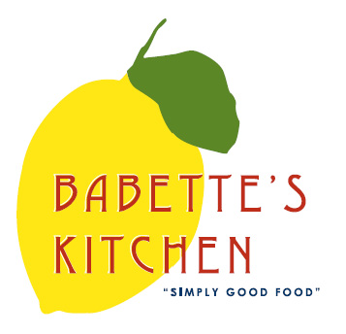
Babette’s Kitchen Menu
Place your order today. Please email your orders to babetteskitchen@gmail.com
Please indicate in the first column the quantity of each item that you would like to order. Menu items are limited and might become unavailable. All orders need to be placed no later than 12noon Tuesday.

Quantity | Unit | Menu Item | Price
 | Quart | Quinoa Tabbouleh Salad | $14
 | Quart | French Lentil Salad | $12
 | Quart | Chili con Carne | $18
 | Quart | Broccoli Cheddar Soup | $14
 | Quart | Sesame Noodles | $24
 | Quart | Potato Salad | $12
 | Each | Bean and Cheese Pupusas (GF) Pack of 6 | $38  w/Salsa
 | Pint | Egg Salad | $12
 | Pound | Locally Smoked Salmon | $35/lb
 | Each | Baguettes | $4
 | Each | Rosemary Toasted Almonds | $8
 |  |  | $8
 |  | **6 min. for Breakfast Items
Quantity | Unit | Breakfast Item | Price
 | Each | Chocolate Croissants | $3.50
 | Each | Croissants | $3.50
 | Each | Raspberry Bear Claws | $1.25
 | Each | Apple Turnovers | $4.50
 | Each | Blueberry Muffins | $4
 | Each | Raspberry Zucchini Bread | $10
 | Each | Chocolate Torte (GF) | $25
 | Each | Trail Mix Bar | $4.50
 | Dozen | Local Farm Fresh Eggs | $6
 | Pound | Babette’s Blend Coffee | $14
 | Each | Gift Certificate – Any Amount
 | ½ Gal | Oat Milk | $5

Name: _______________________________________ Phone number: _________________________________
CC #_______________________exp________________cvv__________billing zip______________
Instructions for Pick-up: PLEASE TELL US WHAT TIME YOU WOULD LIKE TO PICK UP.
PICK UPS WILL BE SCHEDULED BETWEEN 9AM – 3 PM
When placing an order a credit card will be needed for payment. Please text 845-797-4774, pop trunk and food will be placed in it. Do not come into building. Make sure to pick up promptly to avoid contact with other customers.

