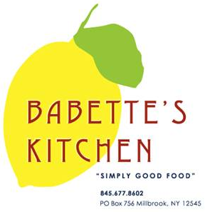
Holiday Menu Advance Order Form

Orders must be placed by Friday, December 16th
Pick-Ups can be scheduled for Friday, December 23rd or Saturday, December 24th
We will be closed December 25th ,26th & 27th. Have a wonderful Holiday.

Please indicate in the first column the quantity of each item that you would like to order.

Quantity | Unit | Menu Item | Price
 | quart | Beef Bourguignon (Serves 2-3) | $40
 | serves  2 - 4 | Butternut Squash & Kale Lasagna | $30
 | serves  6 - 9 | Butternut Squash & Kale Lasagna | $85
 | quart | Corn Pudding | $20
 | each | Baguettes | $4.50
 | each | Quiche Lorraine | $28
 | each | Veggie Quiche | $28

 | Unit | Menu Item | Price
 | each | Lemon Cranberry Tart | $32
 | each | Chocolate Torte (GF) | $35
 | each | Apple Pie | $32
 | each | Holiday Cookie Platter | $40
 | each | Bourbon Pecan Tart | $38
 | each | Croissants | $4
 | each | Chocolate Croissants | $4
 | each | Cherry Scones | $5
 | each | Blueberry Muffins | $3.50
 | each | Gluten Free Cherry Scone | $5

Name: _______________________________________
Phone number: _________________________________
Pick-up day and time:
Friday, December 23rd 10am 11am 12pm 1pm 2pm
Saturday, December 24th 10am 11am 12pm 1pm 2pm

