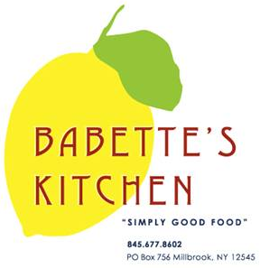
Holiday Menu Advance Order Form

Orders must be placed by Sunday, December 20th.
Pick-Ups can be scheduled for Thursday, December 24th.
We will be closed Christmas Day. Have a wonderful Holiday.

Please indicate in the first column the quantity of each item that you would like to order.

Quantity | Unit | Menu Item | Price
 | quart | Tomato Vegetable Soup | $14
 | quart | Beef Bourguignon (Serves 2-3) | $35
 | serves 9 | Butternut Squash and Kale Lasagna | $75
 | serves  2 or 3 | Butternut Squash and Kale Lasagna | $25
 | quart | Corn Pudding  Serves 4-6 | $18
 | quart | Braised Cabbage with Leeks | $14
 | each | Baguettes | $4
 | dozen | Mini Biscuits | $12
**All scones, muffins and croissants 6 minimum per order

 | Unit | Menu Item | Price
 | each | Ginger Bread Cake | $25
 | each | Buche De Noel | $60
 | each | ½ Buche De Noel | $35
 | each | Apple Almond Tart | $30
 | each | Holiday Cookie Platter | $40
 | each | Sweet Potato Cheese Cake with Meringue Top | $35  (6 inch)
 | each | Croissants | $3.50
 | each | Chocolate Croissants | $3.50
 | each | Cherry Scones | $4.50
 | each | Blueberry Muffins | $3
 | each | Gluten Free Blueberry Muffins | $3

Name: _______________________________________
Phone number: _________________________________
Pick-up day and time:
Thursday, December 24th 10am 11am 12pm 1pm 2pm

