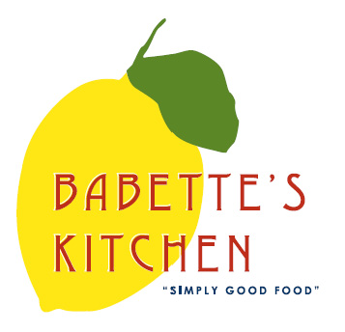
Babette’s Kitchen Menu – Friday January 22nd and Saturday January 23rd
Place your order today. Please email your orders to babetteskitchen@gmail.com.
Please indicate in the first column the quantity of each item that you would like to order. Menu items are limited and might become unavailable. All orders need to be placed no later than 1 pm Wednesday.

Quantity | Unit | Menu Items | Price
 | Each | Kale Caesar Salad Kit for 2 | $16
 | Quart | Organic Brown Basmati Rice | $12
 | Quart | Vegetable Curry (Vegan) | $18
 | Each | Spaghetti Squash Bake with Meatballs & Marinara  (Serves 2-3) Gluten Free | $25
 | Pound | Steelhead Trout Fillets  www.hudsonvalleyfisheries.com | $21
 | Each | Pupusa Box with Salsa  Bean and Cheese Stuffed Corn Tortilla – Gluten Free | $35  Box of 6
 |  | Bakery Items
 | Each | Croissants | $3.50
 | Each | Chocolate Croissants | $3.50
 | Each | Apple Muffin | $3
 | Each | Blueberry Muffin | $3
 | Each | Banana Chocolate Chip Muffin | $3
 | Each | Baguette | $4.00
 | Each | Peach Raspberry Crumb Pie | $25
 | Each | Ricotta Cheese Cake with Blueberry Compote | $25  6 inch
 | 12 oz | Babette’s Blend Coffee | $14
 | Each | House Made Granola | $9
 | Dozen | Farm Fresh Eggs | $6.50
Friday Pick Up__________
Saturday Pick Up_____________

Name: _______________________________________ Phone number: _________________________________
CC #_______________________exp________________cvv__________billing zip______________
Instructions for Pick-up: Please call 845-677-8602 upon arriving at Babette’s.
Please indicate requested time of pick up.

