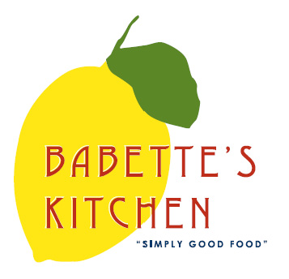
Babette’s Kitchen Menu – Friday, July 10th
Place your order today. Please email your orders to babetteskitchen@gmail.com.
Please indicate in the first column the quantity of each item that you would like to order. Menu items are limited and might become unavailable. All orders need to be placed no later than 1 pm Wednesday.

Quantity | Unit | Menu Item | Price
 | Quart | Gazpacho | $14
 | Bag | Sky Farm Greens | $9
 | Quart | Quinoa Salad | $14
 | Quart | Local Sugar Snaps and Shiitake Mushroom Stir Fry | $16
 | Each | Beef Meatloaves | $9  Serves 1-2
 | Pound | Ready to Bake  Crispy Chicken Tenders | $14
 | Each | Leek and Parm Pastry | $5
 | Each | Tomato Tart | $25
 | Each | Baguette | $4
 | Each | Rosemary Toasted Almonds | $8
 | Pint | Pimento Cheese | $10
 | Pint | Artichoke Dip | $10
Quantity | Unit | Breakfast Item | Price
 | Each | Croissants | $3.50
 | Each | Blueberry Muffins | $3
 | Each | Scones | $4.50
 | Each | Chocolate Croissants | $3.50
 | Each | Raspberry Bear Claws | 3 for $4
 | Each | Big Cookie Box  Cowboy, Funfetti & Oatmeal Raisin 2 each | $18
 | Each | Texas Brownie Cake | $22
 | Each | Peach Blueberry Pie | $25
 | Dozen | Local Farm Fresh Eggs | $6.50
 | 12 oz | Babette’s Blend Coffee | $14
 | Each | House Made Granola | $9

Name: _______________________________________ Phone number: _________________________________
CC #_______________________exp________________cvv__________billing zip______________
Instructions for Pick-up: Please call 845-677-8602 upon arriving at Babette’s. We will bring food out the front door and place on bench. Please indicate requested time of pick up.

