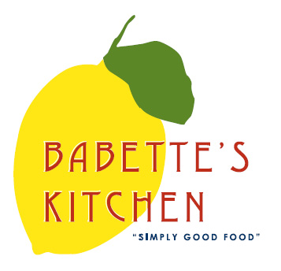
Babette’s Kitchen Menu – Friday October 23rd or Saturday October 24th.
Place your order today. Please email your orders to babetteskitchen@gmail.com.
Please indicate in the first column the quantity of each item that you would like to order. Menu items are limited and might become unavailable. All orders need to be placed no later than 1 pm Wednesday.

Quantity | Unit | Menu Item | Price
 | Quart | Scorched Broccoli with Garlic and Chili Flake | $14
 | Quart | Rosemary Roasted Potatoes | $12
 | Pound | Chicken Tenders  Ready to Bake | $14
 | Pound | Steelhead Trout  https://www.hudsonvalleyfisheries.com  Filets Ready to cook | $21
 |  | Bakery Items
 | Each | Croissants | $3.50
 | Each | Chocolate Croissants | $3.50
 | Each | Apple Turnovers | $4.50
 | Each | Corn Raspberry Muffins | $3
 | Each | NY Crumb Cake Muffins | $3
 | Each | Baguette | $4.00
 | Each | Pumpkin Cake with Cream Cheese Filling & Chocolate Ganache | $28
 | Each | Apple Cranberry Tart | $28
 | Each | Decorated Halloween/Fall Sugar Cookies  (6 minimum per order) | $3.50
 | 12 oz | Babette’s Blend Coffee | $14
 | Each | House Made Granola | $9
 | Dozen | Farm Fresh Eggs | $6.50
 |  | Freezer Sale – Limited Items
 | Quart | Beef Bourguignon | $28
 | Each | Large Lasagna Bolognese  Serves (6-9) | $75
Friday Pick Up__________
Saturday Pick Up_____________

Name: _______________________________________ Phone number: _________________________________
CC #_______________________exp________________cvv__________billing zip______________
Instructions for Pick-up: Please call 845-677-8602 upon arriving at Babette’s.
Please indicate requested time of pick up.

