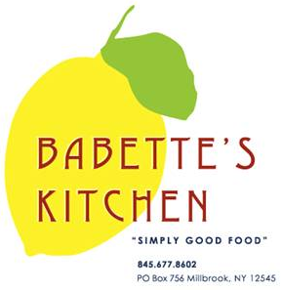
Thanksgiving Menu Advance Order Form

Orders must be placed by Wednesday, November 17th
Pick-Ups can be scheduled for Wednesday the 24th of November
We will be closed on Thanksgiving Day. Have a wonderful Thanksgiving.

Please indicate in the first column the quantity of each item that you would like to order.
**Pints are great for 1 with leftovers or perfect for 2
**Quarts feed 4 – 6 guests
Quantity | Unit | Menu Item | Price
 | quart | Curry Winter Squash Soup | $14
 | quart pint | Traditional Stuffing | $18/qt  $9/pt
 | quart  pint | Corn Pudding | $18/qt  $9/pt
 | pint | Cranberry Sauce  serves 2 – 4 minimum | $10
 | quart  pint | Mashed Potatoes | $16/qt  $8/pt
 | quart  pint | Gravy | $18/qt  $9/pt
 | Each | Baguettes | $4
 | dozen | Biscuits | $30
**All scones, muffins and croissants can be assorted but needs to be 6 minimum per order.
 | Unit | Menu Item | Price
 | each | Bourbon Pecan Tart | $35
 | each | Apple Pie | $30
 | each | Pumpkin Pie | $25
 | each | French Apple Butter Cake (Gluten Free) | $25
 | each | Pumpkin Cheesecake  (Gluten Free) | $45  (8 inch)
 | each | Croissants | $3.50
 | each | Chocolate Croissants | $3.50
 | each | Apricot Scones | $4.50
 | each | Blueberry Muffins | $3.00
 | each | Gluten Free Apricot Scones | $4.50

Name: _______________________________________
Phone number: _________________________________

Pick-up day and time:
Wednesday, November 24th 10am 11am 12pm 1pm Later

